This query calculates the total inventory value of all products by multiplying each product’s price with its stock quantity and summing the result.
The output shows the overall worth of available inventory in the database.

This query is used to count the number of orders for each order status by grouping records using the status column. It shows how many orders are paid, cancelled, shipped, and pending.

Benefit:
Helps understand the current order distribution.
Useful for tracking order processing and business performance.
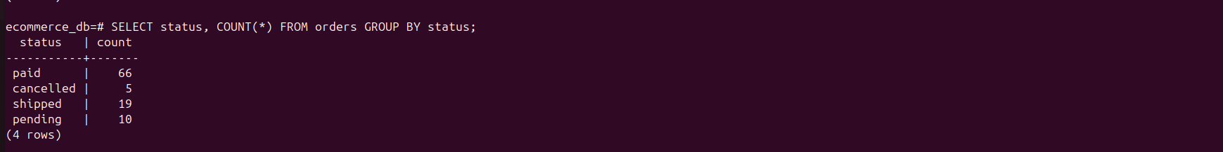

This query is used to calculate the total sales amount for each payment method by grouping orders based on payment_method. It shows how much revenue is generated through Net Banking, Debit Card, UPI, COD, and Credit Card.



